**1.The first task.**

Created a database homework21 and a table Shopping_List:

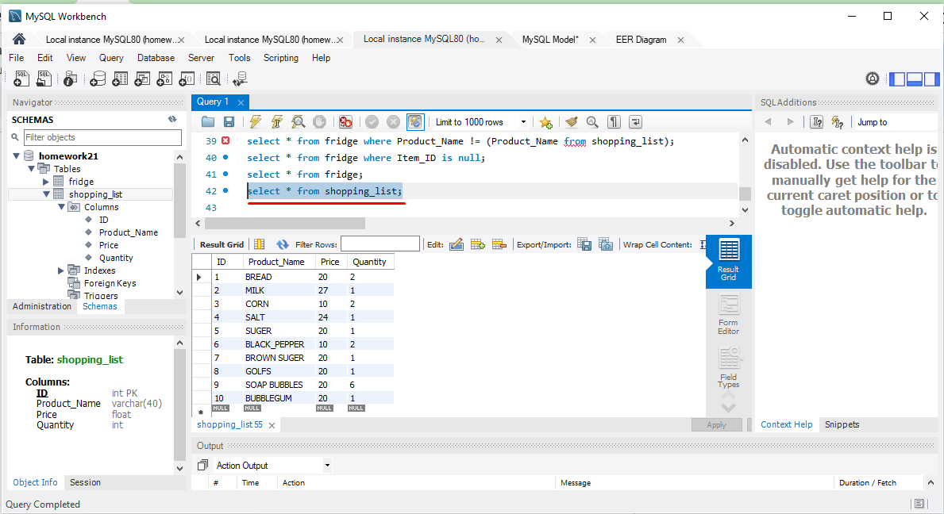

Primary key created:

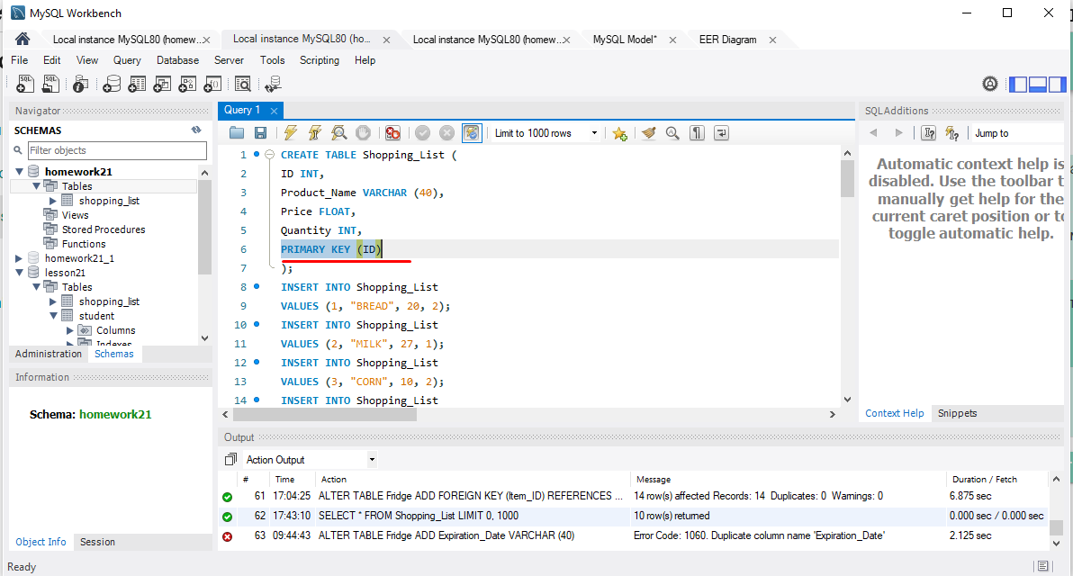

**The second task.**

Created a table Fridge:

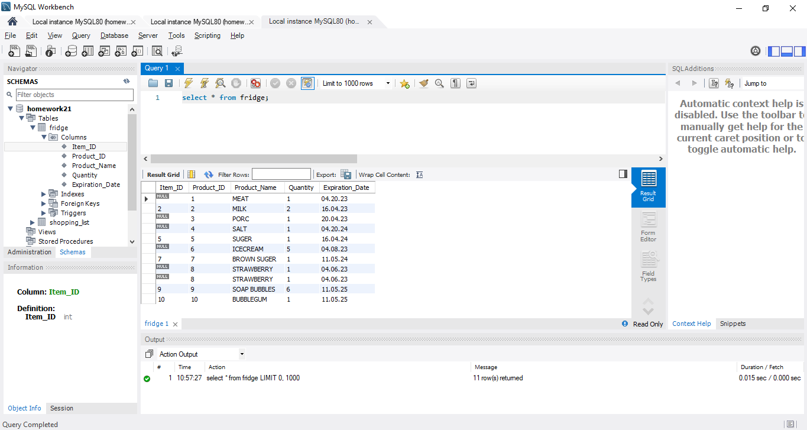

Entity relationship diagram:

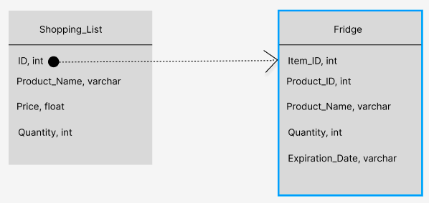

Стовпець ID з таблиці Shopping List - primary key.

Стовпець Item_ID з таблиці Fridge - foreign key.

**The third task.**

Add 10 product names to the Fridge table:

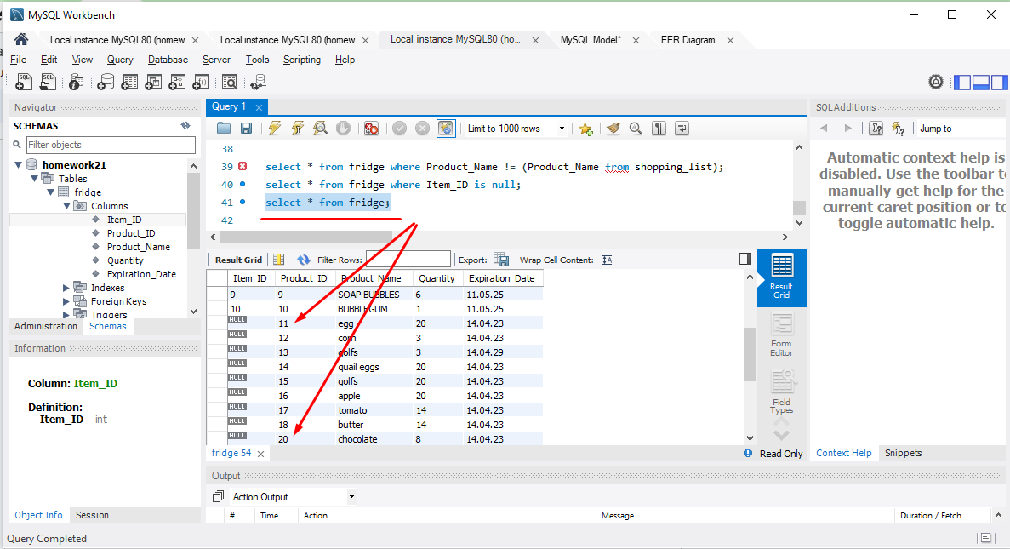

Displaying products that are not in the Shopping_List table:

